Mexico Trip 2020
Monarch Sister Schools &
Monarch Sanctuaries
Itinerary
February 15– 19, 2020

We will travel over the Presidents Day weekend, departing early on Saturday, Feb. 15, 2020 and returning late Wednesday, February 19, 2019 (unless you decide to stay longer). The first afternoon in Mexico City, we start with a City Tour of the historic center and world-famous Zócalo (central square), followed by a ‘Welcome Dinner’. The second day we travel to nearby Teotihuacan to see the ‘Pyramid of the Sun’, the world’s third largest, followed by a tour of one of the world’s top 10 museums, the National Museum of Anthropology. On Days 3 and 4, we visit Monarch Country, including our local sister schools and the largest and most famous of the Monarch butterfly sanctuaries, El Rosario, where millions of Monarchs congregate to overwinter.

LAND PACKAGE – Itinerary.

MEXICO CITY
Feb. 15th – Saturday
- Arrival at Mexico City Airport (by 1:45 pm) – Our tour guide will meet us outside of International Arrivals.
- City Tour of Historic District, including Zócalo square, Templo Mayor and the Presidential Palace.
- Check-in at Hotel Casa Blanca (near the Reforma Blvd. & Monument to the Revolution).
- Evening: Welcome dinner with live Mexican music and authentic Mexican cuisine.
Feb. 16th - Sunday
- Breakfast / Excursion to the Pyramids of Teotihuacan led by guide Alexander Ramirez Cruz.
- 2:00 pm. Early Sunday dinner, then tour of the famous National Museum of Anthropology highlighting Mexico’s amazing pre-colonial civilizations of Mesoamerica / / Evening: Free
MONARCH COUNTRY
Feb. 17th - Monday
- Breakfast / Early departure from Mexico City to ‘Monarch Country’ (a 2-hour trip in our mini-bus).
- Late morning: Visit to the ‘El Rosario’ Monarch Sanctuary with a local guide.
- Mid-afternoon: Home-style meal served by local women of ‘El Rosário’
- Stay at the Hotel Villa Monarch / / Evening: Free
Feb. 18th - Tuesday
- Morning: Breakfast / Visit to two Monarch Sister Schools (Leona Vicário & Forest Middle School)
- Excursion to charming Angangueo – a traditional silver mining town
- Guided tour of our partner Alternare’s Sustainable Agricultural Training Center that works the communities that own the lands of the Monarch Butterfly Biosphere Reserve.
- Farewell Dinner / / Stay at the Hotel Villa Monarch
Feb. 19th - Wednesday
- Early Morning: Breakfast
- Departure for Mexico City / 10:15 am.: Arrival at International Airport

Early Bird Pricing (if paid by 12/21/19): $1,195 per person (dble occupancy) / $175 Single Sup.
After 12/21/18: $1,295 per person (dble occupancy) / $175 Single supplement.

Payment in full or a minimum deposit of $250 is required to hold your place. Space limit: 18.
Note: Please make your check payable to Natural Partners and mail to:
William Dent / 4740 Connecticut Ave NW Suite 1012 / Washington, DC 20008.

Air travel: Each trip participant will book his/her own airline reservations for a flight that arrives no later than 1:45 pm on Saturday, Feb. 15, 2020. If you plan to arrive the day before, please let us know. We can book the extra night for you.

Two-day Extension is available after the main 4-day trip for those who wish to see more of Mexico City or other attractions in Monarch Country. If interested, we will send you the 2-day itinerary.

The land package price includes:

- Hotels: Two nights in Mexico City + two nights in Monarch Country.
- Meals: Breakfast and the main meal of the day, plus on arrival day, the Welcome Dinner.
- Tour services: Alexander Ramirez Cruz (first two days) / William Dent (entire tour)
- Transportation (private Mercedes mini-bus) to and around “Monarch Country”.
- Admission fees to the Teotihuacan archeological & pyramid site; the National Museum of Anthropology; and to the ‘El Rosário’ Monarch Butterfly Sanctuary.

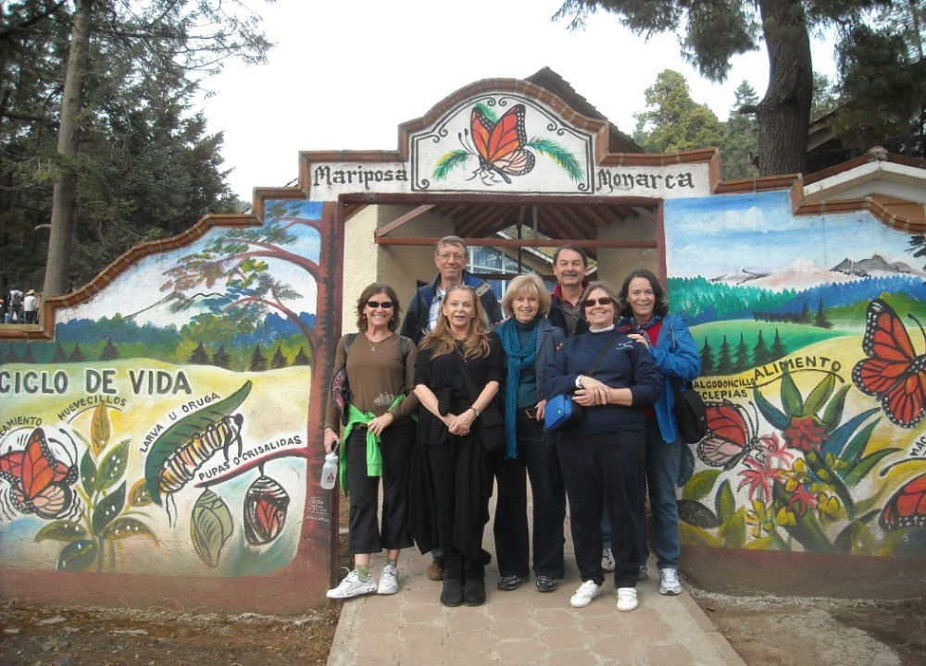
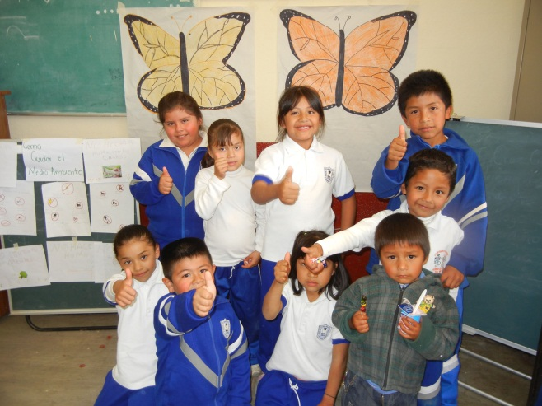

Arrival of first tour group in 2012 at the entrance to ‘El Rosario’ Monarch Sanctuary (top);
Students at sister school ‘Leona Vicario’ Elementary (lower picture)

FOR ADDITIONAL INFORMATION, Please contact William Dent by phone or email.
Email: williamdentjr@gmail.com // Phone: (202) 487-5343.

